Assignment 2

Problem Statement: To design and implement an e-commerce application replicating the core features of existing ecommerce applications like Flipkart. The application should support both user and admin interfaces, enabling functionalities such as product browsing, cart management, user authentication, order tracking and payment integration,

Introduction:
In today’s digital era, e-commerce applications play a pivotal role in shaping user experiences by offering convenience, speed, and personalization. Customers expect intuitive interfaces, quick checkouts, accurate delivery updates, and a tailored shopping journey. This is a comprehensive full-stack project that emulates the key features of Amazon, delivering a robust and user-friendly e-commerce solution. It enables users to browse products, manage carts, authenticate securely, and track orders, while providing a dedicated admin panel for inventory management, order handling, and business analytics.

Objectives:

- Design and develop a responsive, cross-platform mobile frontend using Flutter.
- Build a scalable backend using Node.js and RESTful APIs for seamless communication.
- Enable real-time tracking of products and orders to enhance user engagement and trust.
- Integrate secure payment gateways and implement push notification systems for timely updates.
- Provide a dedicated admin interface for efficient product management, order oversight, and system analytics.

Key Features of this Ecommerce:

User-Side Functionality
- Secure authentication using email and password.
- Browse and filter products based on categories for easier discovery.
- Rate and review products after purchase to share feedback.
- Add items to the cart, proceed to checkout, and place orders seamlessly.
- Access order history and track the status of current orders in real time.

Admin-Side Functionality
- Add, edit, or delete products through an intuitive admin interface.
- Update and manage order statuses to reflect real-time changes.
- View analytics based on product categories to monitor performance and sales trends.

Solution Approach
This project adopts a robust, scalable, and modern architecture utilizing cutting-edge tools and frameworks for both the frontend and backend systems.
Frontend
- Flutter (v3.x): Builds a high-performance, cross-platform mobile application compatible with both Android and iOS.
- Dart: The core language behind Flutter, enabling smooth UI rendering, animations, and performance-optimized interactions.
Backend
- Node.js (v18.x): A powerful JavaScript runtime used to develop scalable, event-driven server-side applications.
- Express.js (v4.x): A fast and minimalist web framework for building RESTful APIs and handling middleware.
- Mongoose ODM: Provides schema-based modeling for MongoDB, including validation and database abstraction.
Database
- MongoDB Atlas: A flexible, cloud-based NoSQL database used to store user data, products, orders, cart details, and more.
Payment Integration
- Google Pay: Seamlessly embedded into the Flutter app for fast, secure, and reliable order checkout.
🛠️ Development Tools & Environment
- Git & GitHub: Version control and collaboration tools for source code management.
- Pycharm: The primary IDE for frontend and backend development.
- Postman: Used extensively for API design, testing, and debugging.
- Environment Configuration: Handled securely via .env files for sensitive keys like MONGODB_URI, JWT_SECRET, FCM_SERVER_KEY, and email credentials.

Setup Instructions:

- Clone the Repository:
git clone https://github.com/lahirisoham2004/LAB/IT/ECOMMERCE
- Install backend dependencies.

- Setup environment variables in `.env`: MONGO_URI,JWT_SECRET,EMAIL_ID, EMAIL_APP_PASSWORD, REDIS_URL.
- Start the backend server:
- Run the Flutter frontend.

Design Pattern:
This project is built on a robust three-tier architecture, ensuring scalability, maintainability, and a smooth user experience. The system is structured around clear separation of concerns across the client, server, and database layers.
1. Client Layer (Frontend – Flutter)
The frontend is developed using Flutter, delivering a responsive and cross-platform user interface for Android and iOS devices. It communicates with the backend through RESTful APIs, handling:
- Product browsing and search
- Cart operations and order placement
- User authentication and profile management
- Real-time order status tracking
Additionally, Firebase Cloud Messaging (FCM) is integrated for push notifications, including alerts for product restocks.
2. Server Layer (Backend – Node.js & Express.js)
The server layer is implemented using Node.js and Express.js, responsible for handling HTTP requests, executing business logic, and securing communications. Key functionalities include:

- Routing: Manages API endpoints for user and admin actions such as login, cart management, checkout, and product operations.
- Authentication: Secured using JWT (JSON Web Tokens) for both users and admin roles.
- Business Logic: Encapsulated in controllers to manage operations like order processing, cart updates, product management, and analytics retrieval.
- Email Services: Utilizes Nodemailer and PDFKit to send order confirmations and generate downloadable receipts.
3. Database Layer (MongoDB)
The data layer is powered by MongoDB Atlas, a cloud-hosted NoSQL database optimized for flexibility and performance. It stores all essential data in well-structured collections:
- Users: Maintains account details, cart data, authentication tokens, and order history.
- Products: Contains product information such as name, brand, description, price, quantity, images, ratings, and tags.
- Orders: Records all order transactions, including payment status, shipping information, timestamps, and user references.

Data Flow:

This application follows a streamlined data flow across its three core layers—client, server, and database—to support both user and admin operations. It effectively manages essential e-commerce features like product browsing, ordering, inventory updates, and administrative controls.

- User Interaction (Client-Side – Flutter App)

Users interact with the system through a Flutter-based mobile application, which communicates with the backend using RESTful APIs. The client-side is responsible for initiating requests and displaying responses in a responsive UI. Key user-side functionalities include:
- Authentication:
Users can register or log in using OTP-based phone verification. Sessions are securely maintained using JWT tokens.
- Product Browsing:
Search and filter products by categories, tags, ratings, and other attributes to find items quickly and easily.

- Cart Management:
Users can add, remove, or update items in their shopping cart in real time.
- Order Placement:
Select shipping options and confirm purchases with integrated payment options like Google Pay.
- Profile Management:
View and edit personal details, manage saved addresses, and review past orders.
- Notifications:
Receive real-time push alerts using Firebase Cloud Messaging for important events such as order status updates and restock alerts.
- Invoice & Receipts:
After a successful order, a PDF invoice is automatically generated and sent via email, providing users with a downloadable receipt.

- Admin Interaction (Admin Panel)
The admin panel is built to provide complete control over the application's backend operations, allowing administrators to manage inventory, monitor orders, analyze data, and oversee user activity. All admin operations are secured through access-controlled routes and interfaces.

a. Product Management
- Create, update, or delete product listings.
- Upload product images and define attributes such as price, quantity, category, tags, and brand.

b. Inventory Monitoring
- Track stock levels in real time.
- Receive automated alerts when inventory falls below predefined thresholds.

c. User Management
- View a list of registered users and their interaction history.
- Block or restrict access to specific users in cases of suspicious or fraudulent behavior.

d. Order Tracking
- Monitor active and completed orders.
- Update shipment statuses and generate QR codes for delivery tracking.

e. Notification Broadcasting
- Schedule and send restock alerts or promotional emails to interested users using integrated email utilities.

f. Analytics & Insights
- Access key business metrics such as:
  - Best-selling products
  - User growth trends
  - Daily transactions
(Note: Advanced analytics features are planned for future integration.)
All admin-side actions communicate with the backend via protected API endpoints and directly interact with the MongoDB database to reflect changes in real time.
- Request Processing (Backend – Node.js + Express.js)
The backend, built using Node.js and Express.js, acts as the central processing unit of the application. It handles both user and admin requests, ensuring proper routing, execution of business logic, and secure data handling.

a. Authentication Middleware
- Ensures secure access by validating JWT tokens for user sessions.
- Applies role-based access control to differentiate between user and admin privileges.

b. Route Handling
- API endpoints are logically organized and separated to handle distinct operations for:
  - Regular users (e.g., product browsing, cart operations, placing orders).
  - Admin users (e.g., product management, analytics, inventory control).

c. Controllers and Services
These modules contain the core business logic, handling tasks such as:
- Stock verification before confirming orders.
- Total calculation and PDF receipt generation post-checkout.
- Form validation and security checks to prevent invalid or unauthorized requests.

d. Utility Modules
Supporting functions that enhance backend capabilities include:
- PDF generation for invoices using PDFKit after successful orders.
- Email service using Nodemailer to send OTPs and confirmations with randomized sender addresses for security.
- QR code generation for delivery tracking or product pickup, improving transparency and customer convenience.

- Database Interaction (MongoDB)
The application uses MongoDB as its primary database, leveraging its flexible, document-oriented structure with embedded documents and collections. This supports both user-facing and admin-facing functionalities.

User-Side Collections
- Users Collection:
Stores user profiles, cart contents, addresses, and order history.
- Products Collection:
Holds details like product name, price, quantity, brand, tags, average ratings, and image URLs.
- Orders Collection:
Maintains order records with references to user profiles and the products involved in each purchase.

Admin-Side Collections
- Admin Logs Collection (optional):
Keeps a record of administrative actions for auditing and tracking.
- Categories/Tags Collections:
Organizes products by type and supports advanced filtering in search and analytics.
- Inventory Alerts (planned feature):
Flags low-stock items and can trigger restock notifications automatically.
Performance Optimization:
All key fields—such as product IDs, user IDs, and category names—are indexed to ensure fast and efficient querying across large datasets.

5. Response Delivery (JSON to Frontend)
After processing each request, the backend sends structured JSON responses to the Flutter frontend, ensuring smooth real-time interactions.

For Users
- Updated cart information
- Product listings and search results
- Order confirmation messages
- Relevant error messages (e.g., out-of-stock, authentication failure)

For Admins
- Confirmation of product or inventory updates
- Order and shipment tracking data
- System feedback and analytics summaries

Notifications
- Push Notifications via Firebase Cloud Messaging (FCM)
- Email Notifications with order receipts and updates, enhancing communication and user satisfaction
The frontend parses these JSON responses to dynamically update the UI, providing a fast and responsive experience for both users and admins.

6. Optional Utility Services
To extend functionality and enhance user experience, several backend utility services have been integrated:

a. Email Service
- Sends order confirmation emails
- Attaches PDF invoices for completed purchases using PDFKit

b. Notification Services
- Implements a restock alert system using Redis Pub/Sub and Firebase
- Sends targeted notifications to users who have opted to be informed when products are back in stock

Database Schema:
Users:
- Stores user details such as name, email (with format validation), and a hashed password.
- Also includes address information, user type (default: "user"), and an embedded cart array.
- Each cart item references a product (embedded product schema) along with the quantity.
Products:
- Contains metadata such as product name, description, brand, image URLs, price, quantity, category, and optional tags.
- Tracks units sold (soldCount), average rating (avgRating), and a list of user ratings (each containing userId and rating value).
Orders:
- Includes a list of ordered products, each with embedded product details and quantity.
- Stores total price, shipping address, userId (as a string), order timestamp (orderAt), and order status (default: 0 for pending).
- Tracks the complete order history and current status of each order.

Class Overview:

Class: User

Attributes:

name: String

email: String

password: String

address: String

type: String = "user"

cart: List<CartItem>

Relationships:

Has a list of CartItem

Places 0..* Order

Class: Order

Attributes:

products: List<OrderItem>

totalPrice: double

address: String

userId: String

orderAt: long

status: int = 0

Relationships:

Contains multiple OrderItem

Class: CartItem

Attributes:

product: Product

quantity: int

Relationships:

References one Product

Class: OrderItem

Attributes:

product: Product

quantity: int

Relationships:

References one Product

Class: Product

Attributes:

name: String

description: String

brand: String

imageUrls: List<String>

quantity: int

price: double

category: String

tags: String

soldCount: int = 0

avgRating: double = 0

ratings: List<Rating>

Relationships:

Has multiple Rating

Class: Rating

Attributes:

userId: String

rating: int

Relationships:

Belongs to a Product

Design Patterns & Code Organization
This project follows proven architectural patterns to ensure clean separation of concerns, modularity, and scalability for both the backend and mobile frontend.

1. Model-View-Controller (MVC)
The project adopts the MVC pattern throughout its backend and frontend architecture:
- Models: Defined using Mongoose to represent data entities like User, Product, and Order.
- Controllers: Responsible for handling business logic (e.g., cart management, order placement) and interacting with models to process client requests.
- Views: The frontend is built with Flutter, acting as the view layer, rendering responsive UI based on JSON responses from the backend.
This separation ensures that backend development remains independent from frontend presentation, enabling more efficient iteration and testing.

2. Pub/Sub Pattern (Redis + FCM)
The notification system uses the Pub/Sub pattern with Redis and Firebase Cloud Messaging (FCM):
- Backend events (e.g., successful order placement) are published to Redis channels.
- A subscriber listens for these events and handles FCM push notifications, ensuring timely and decoupled delivery.
- The isBan flag is stored in Redis to manage user logins, ensuring only one valid FCM token is used per device.
Challenges & Solutions
1. Handling Firebase Notifications Across Multiple Logins
- Challenge: Multiple users can log in and out on the same device, leading to conflicts in Firebase Cloud Messaging (FCM) tokens and mismatched notifications.

- Solution: A Redis-based token management system was implemented, utilizing an isBan flag to track the validity of tokens. This ensures only the active user’s session receives notifications, preventing cross-user notification leakage.
2. Secure & Seamless Payment Integration
- Challenge: Ensuring reliable order confirmation after payment while managing edge cases such as app closure or network interruption during payment processing.
- Solution: Google Pay was integrated with robust backend verification logic. The order is only confirmed and saved after receiving a confirmed payment status from the gateway, preventing duplicate or phantom orders and ensuring transactional reliability.
3. Efficient Handling of Large Product Catalog
- Challenge: Managing a large number of products and categories efficiently while ensuring fast search and filtering capabilities for the frontend.
- Solution: Implemented efficient indexing and caching mechanisms on the backend using MongoDB’s full-text search and Redis. This allows for quick product searches and filtering, improving performance even with a large catalog.
4. Handling Concurrent User Actions
- Challenge: Managing simultaneous actions (e.g., cart updates, order placement) from multiple users without causing data inconsistencies.
- Solution: Utilized optimistic concurrency control and transaction management in MongoDB to ensure that updates to critical data (e.g., inventory levels, cart contents) are consistent and handled correctly across multiple concurrent sessions.
5. Scalability of User Authentication
- Challenge: Ensuring fast and secure authentication for a large number of users while preventing security risks like session hijacking and token tampering.
- Solution: Adopted a JWT-based authentication system with token expiration and refresh mechanisms. To further enhance security, implemented multi-factor authentication (MFA) for high-risk actions, ensuring a robust and scalable authentication process.
6. Real-Time Inventory Management
- Challenge: Ensuring that product inventory is accurately updated in real time across multiple devices and sessions.
- Solution: Leveraged WebSockets to implement real-time updates for inventory status. This ensures that any changes in stock are instantly reflected on all user devices, reducing the chances of overselling.

Testing & QA
- Manual UI Testing on Android: Performed comprehensive manual testing of the user interface on Android devices to ensure smooth and intuitive interactions.
- API Testing with Postman: Used Postman to test all major backend API endpoints, ensuring they work as expected under various scenarios.
- Edge-case Handling: Special focus was placed on edge-case scenarios, such as handling missing stock, broken image links, and other potential issues that could impact the user experience.

Conclusion & Future Scope
This project provides a robust and scalable foundation for building e-commerce platforms. It successfully integrates key e-commerce features while leveraging a modern tech stack and modular architecture.

Future Enhancements:
- Product Recommendation System: Implement a machine learning-based product recommendation engine to personalize user experiences.
- Payment Aggregator Integration: Add support for additional payment gateways, such as Razorpay, to provide more payment options.
- Live Order Tracking with WebSockets: Use WebSockets to enable real-time order tracking, enhancing user engagement and satisfaction.
- CI/CD Pipeline & Test Automation: Set up a continuous integration/continuous deployment (CI/CD) pipeline and automate testing processes to streamline development and improve code quality.

Output Screenshots(User Side):


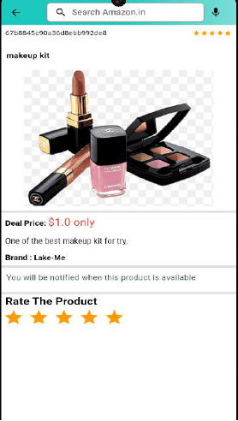


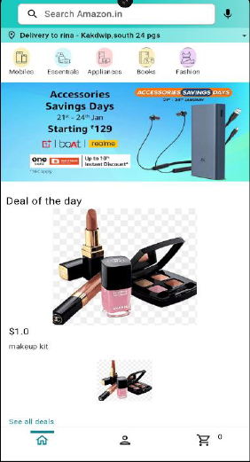
Deal Price: $456.00 (5% Off) Valid Till Today
HP Pavillion with Nvidia A100 GPU
Brand: HP
Laptop
$456.00
Laptop
Home Option with Search Bar

Item Details Screen

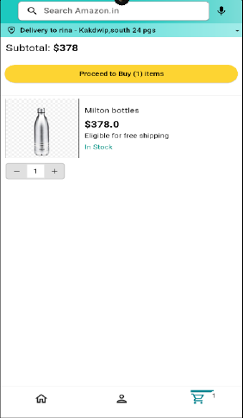
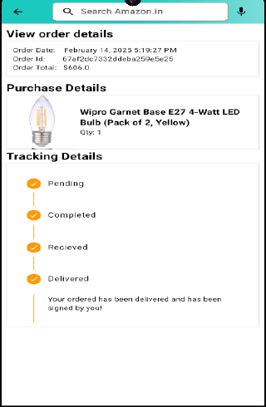
Subtotal: $456.00


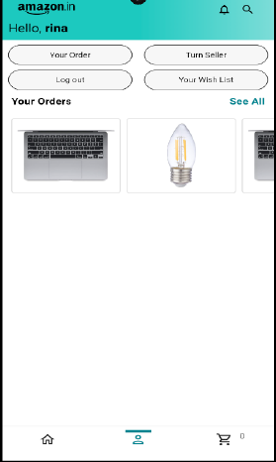

Order History
Track Order
HP Pavillion Laptop
$456.00
In Stock
HP Pavillion Laptop
Qty: 1

Add to Cart and Proceed to Buy

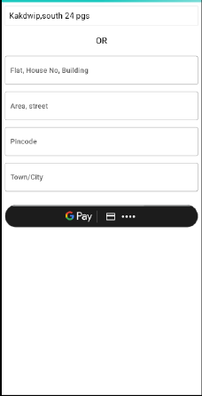
28/3 Chowdhury Para

Pay and Check-Out

Output Screenshots(Admin Side):


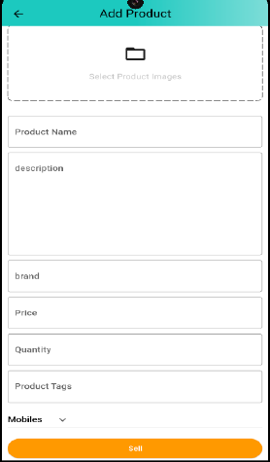
Product Add Screen
Edit Item Details

